SH302C Portable oil particle contamination meter
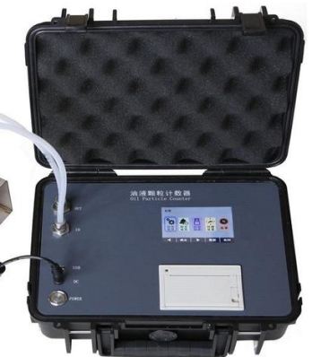

The SH302C portable oil particle contamination meter adopts the counting principle of the light blocking (shading) method specified by the International Hydraulic Standards Committee, and is specifically used as a rapid detection device for on-site oil contamination levels.
It has the advantages of small size, light weight, fast detection speed, high accuracy, and good repeatability, and can work under high temperature, high pressure, and other harsh conditions. Built in micro water sensor and temperature sensor, it can detect both water content and oil temperature while detecting contamination. It is suitable for transformer oil (i.e. insulating oil), hydraulic oil, lubricating oil, synthetic oil, and other fluids, and can be widely used in aerospace, petrochemical, transportation and port, steel metallurgy, automobile manufacturing, and other fields.

Key Features
- Adopting the principle of light blocking (shading) method, using high-precision laser sensors, featuring small size, high accuracy, and stable performance
- Suitable for laboratory or on-site testing, as well as optional pressure reducing devices for online high-pressure measurement and real-time monitoring of particle contamination in the oil system
- Can be externally connected to a pressure chamber to form positive/negative pressure, enabling the detection of high viscosity samples and sample degassing
- Built-in data analysis system, which can display the true data of particle size of each channel and automatically determine the sample grade
- The pipeline is made of 316L and PTFE materials to meet the requirements of various organic solvents and oil detection
- With volume flushing and duration flushing modes, it is convenient for users to use and maintain the equipment
- Built in ISO4406, NAS1638, SAE4059 (integral and differential), GJB420A, GJB420B Г OCT17216, GB/T14039 and other particle pollution level standards
- Built-in calibration function, which can be calibrated according to standards such as GB/T21540, ISO4402, and GB/T18854
- Built in data analysis system, capable of automatically determining sample grade based on standards, with automatic data processing and printing functions
- Built-in micro water sensor and temperature sensor
- Bilingual Chinese and English, one button switch, with preset, input, modification, and storage functions, convenient and fast operation
- Large storage, optionally stored in internal or external storage devices of the instrument
- Embedded design, high-strength housing, easy to carry, suitable for all types of construction machinery
Technical indicators
Light source | Semiconductor laser
Offline detection speed | 5-60mL/min
Offline testing of sample viscosity | ≤100cSt
Online pressure detection | 0.1-0.6Mpa
Particle size range | 1-500μm
interface | USB interface, power interface
data storage | Provide 1000 sets of data storage space and support USB flash drive storage
Sensitivity | 0.8μm or 4μm（c)
Limit coincidence error | 40000 capsules/ml
Counting volume | 1-999ml
Counting accuracy | Error less than±10%
Protection level | IP67
Test interval | 1 second to 24 hours时
Test sample temperature | 0-80℃
Reference value of Water activity | 0-1aw（±0.05aw）
water content | 0-360ppm（±10%）
working temperature | -20-60℃
Power supply | DC12V
Screen size | 10.2 inches
Battery capacity | 8000mAh
Size：365×295×170mm Weight： 5.5kg

BX-1 Portable pressure sampler (optional)
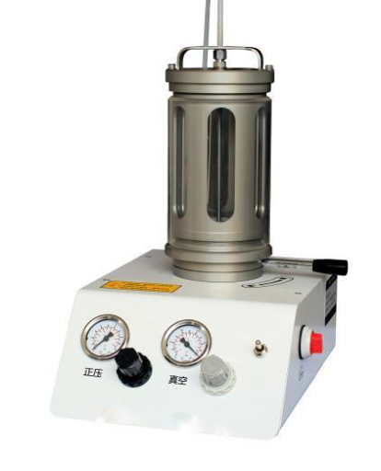

The BX-1 Portable Pressure Sampler is a device used to assist in the sampling of high viscosity samples, which can be used to assist in the sampling of portable oil particle counters. The pressure sampler has a built-in pressure pump that can directly switch between positive and negative pressures, and can store and maintain pressure for a long time. It has the advantages of reliable structure and stable performance. BYQ-1 portable pressure sampler is easy to operate, has a wide pressure range, and is widely used.
Performance characteristics

- Built-in pressure pump, fast pressure boosting speed;
- Positive and negative pressure can be switched, with strong pressure retaining ability;
- Can assist in the injection of high viscosity oil samples, improving the viscosity of samples detected by portable particle counters;
- Built-in pressure sensor, arbitrary setting of pressure values, high degree of intelligence;
- Mechanical and computer models available for selection;
- Compact structure, small size, light weight, and easy to carry.

Technical indicators
- Positive pressure range: 0-600kPa
- Negative pressure range: 0-80kPa
- Working temperature: 10~40 ℃
- Power supply: AC 110-220V, 50/60Hz, ≤ 120W

